SUPPLEMENTARY MATERIALS [SM] for:

Disintegration at the Syntax-Semantics Interface in Prodromal Alzheimer’s Disease: New Evidence from Complex Sentence Anaphora in Amnestic Mild Cognitive Impairment (aMCI)

Authors: Barbara Lust, Suzanne Flynn, Charles Henderson, James Gair, and Janet Cohen Sherman

This PDF file includes:

1. Supplementary Linguistic Notes
1.1. Binding and Coreference
1.2. C-command
2. Materials and Methods:
2.1. Participants
2.2. Cognitive Tests
2.3. Scoring Criteria for Linguistic Tasks
3. Figures
Figure S1. Correct Production of ASC Sentences with Semantic Plausibility (+SP)
Figure S2: Correct Production of ASC Sentences with Semantic Implausibility (-SP)
Figure S3: Correct Production of CS Sentences with Semantic Plausibility (+SP)
Figure S4: Correct Production of CS Sentences with Semantic Implausibility (-SP)
Figure S5. Relation of HA and aMCI performance on Psycholinguistic Task (Adverbial Subordinate Clauses) to Performance on BP (Brown Petersen) verbal working memory test
Figure S6. Relation of HA and aMCI performance on psycholinguistic task (Adverbial Subordinate Clauses) to performance on ACE-R Memory Test

4. Tables
Table S1. Major Error Categories in ASC Experiment
Table S2. ASC Experiment Anaphora Errors (RBB vs. RBF) (+SP)
Table S3. ASC Experiment Anaphora Errors (RBB vs. RBF) (-SP)

5. Supplementary References

6. Abbreviations

1. SUPPLEMENTARY LINGUISTIC NOTES
1.1. Binding and Coreference
In later work, Reinhart’s anaphora typology (2006, p. 165 f) recognized that construal mechanisms are not limited to referential cases (see also Heim, 1998). For example, antecedents may be non referential, e.g., quantifiers, and thus pronoun interpretation need not involve reference, e.g., “No boy brought his teddy bear to the party” (Reinhart, 1986, p. 124). Yet both forms of anaphoric construal are available. Thus she suggests the actual distinction is between “bound” anaphora and “covaluation”. Since the sentences in our present experiment involve referential noun phrases we will continue the more common labeling as “bound anaphora” vs. “coreferential anaphora”. Reinhart (2006) defines “covaluation”: “α and β are covalued iff neither A-binds the other and they are both assigned the same value” (Reinhart, 2006, p. 172).
Decades of research in linguistics continue to pursue the structural representations and related computations involved in knowledge of anaphora and binding as well as the precise definition of “c-command” (e.g., Büring, 2005; Bruening, 2014, Reinhart, 1981) and a precise theory of pronouns (e.g., Johnson, 2013; Collins & Postal, 2012); they have also pursued the analysis of discourse context by which free reference is computed (e.g., Gundel & Hedberg, 2008; Mak & Sanders, 2010; Patel-Grosz et al., 2018). Research has debated the degree to which the facts and the constraints on anaphora can be best explained from the domain of syntax (e.g., as in Binding Theory) (e.g., Reinhart, 1983a,b and forward; or semantics Heim, 1998; Heim & Kratzer, 1998; cf., Fox, 2000) or pragmatics (Johnson, 2013; Jacobson, 2022).
Without considering the various possible implementations of the syntactic and semantic facts relevant to Binding Theory, our experimental design involves the basic assumptions which underlie most all current analyses: two distinct forms of anaphoric construal and the structural notions of hierarchy and dominance underlying linguistic notions of ‘c-command’.

1.2. C-Command
A Tree Showing c-command by a pronoun (he) of a noun subject (electrician). Anaphora is not possible between ‘He’ and ‘electrician’.
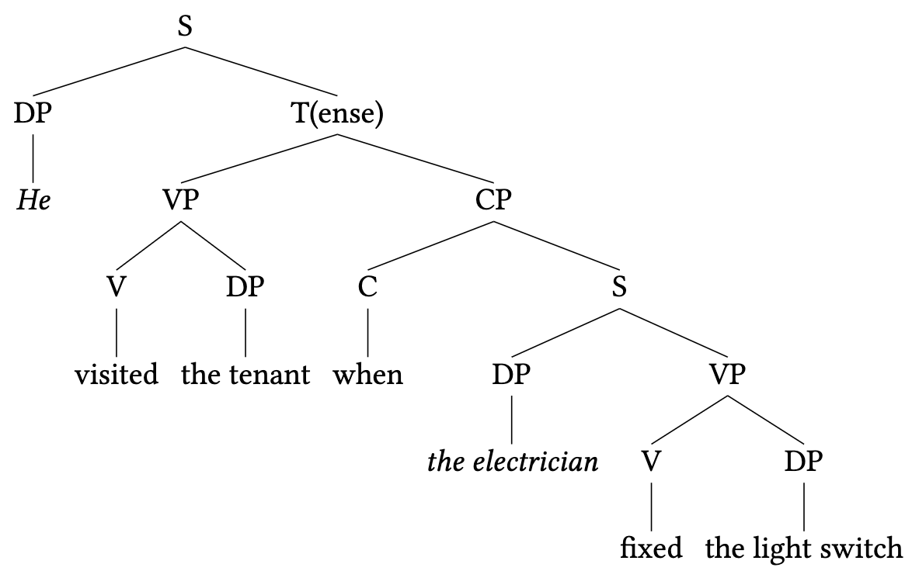

General Definition of C-Command
“a c-commands b iff a is a sister to a category y containing b” (Reuland, 2011, p. 29).
See Figure 5 in the main paper for proposed representation of the pronoun.

2. MATERIALS AND METHODS
2.1. Participants
MCI Participants
MCI participants at Massachusetts General Hospital (MGH) were referred by their neurologists for clinical neuropsychological evaluation to the Psychology Assessment Center (PAC), a neuropsychological evaluation center within MGH. The patients were referred to address concerns about changes in memory and/or other aspects of cognitive functioning; they were recruited for participation in this study. MGH PAC participants were diagnosed with aMCI based on neurological evaluation, including Clinical Dementia Rating (CDR) (Morris, 1993) and performance on neuropsychological cognitive tests from the Uniform Data Set (UDS) (Morris et al., 2006; Weintraub et al., 2009), developed by the National Alzheimer’s Coordinating Center. The measures assess attention, processing speed, executive functioning, episodic memory, and language. MGH PAC participants also received additional standardized neuropsychological measures. Consistent with consensus criteria, individuals with aMCI showed evidence of cognitive decline on neuropsychological testing from baseline as estimated by their performance on a measure of single-word oral reading (North American Reading Test (NART)) and also showed preserved independence in managing activities of daily living according to informant report (as assessed on the Activities of Daily Living–Questionnaire (ADL-Q, Johnson et al., 2004)).
MCI participants at the MGH Alzheimer’s Disease Research Center were tested by one of our trained assistants on the psycholinguistic coordinate clause test. Like the aMCI participants recruited from the PAC, they were categorized as aMCI through similar consensus criteria with diagnoses based on neurologist evaluation, including CDR and performance on the UDS. Based on neurological examinations that often included imaging and laboratory tests as well as clinical exam prior to referral for neuropsychological evaluation, medical history was obtained to rule out other contributing causes for cognitive decline (e.g., stroke, brain tumor, metabolic/infectious causes) in both aMCI groups.
HA Participants
The 24 HA participants included 14 assessed at Cornell University and 10 at the MGH PAC. The Cornell HA participants were part of an Older Adult Respondent Pool created by the Cornell Institute for Translational Research on Aging (CITRA), where subjects ages 60 or older were recruited based on their interest in research participation and screened to determine normal health status. These participants were categorized as HA based on self-report supplemented by a sociodemographic questionnaire (at Cornell University) where they were reported to have no history of neurological events and no evident language or memory deficits. The 10 HA who were assessed at MGH were recruited through the MGH ADRC and tested at PAC. These participants were confirmed as HA based on assessment with the CDR and ACE-R testing replicating that applied to the aMCI population. Ten HY, presumably at the height of memory skills (Park et al., 2002), were recruited from MIT (six students, four employees, i.e., research assistant, lab technicians, administrative assistant). Basic demographics of the HY, two HA groups, and two aMCI groups are provided in Table 3.

2.2. Cognitive Tests
Addenbrooke’s Cognitive Examination – revised: The total ACE-R test score (Mioshi et al., 2006) ranges from (0-100). Within this, the ACE-R, The Memory component (26 points) includes immediate recall of a name and address across three repeated learning trials (0-7), recall of three words (0-3) following a brief delay, and of the name and address (0-7) following a longer delay, for which recognition of elements not freely recalled is also assessed (0-5), and retrograde memory (0-4) for general information.
Brown-Peterson Test of Working Memory: The BP Auditory Consonant Trigram Task (Belleville et al., 2007) asks participants to recall orally presented random consonant trigrams after 0, 9, 18, and 36-second delays during which the individual performs a distractor serial subtraction task; total score is based on overall number of consonants correctly recalled. Subjects are scored for number of letters correctly remembered for each trial under the several delay conditions (0, 3, 9, and 18 sec).

2.3. Scoring Criteria in Elicited Imitation Experiments
Criteria for Scoring Alzheimer’s Study ASC (left) and CS (right) Elicited Imitation Data
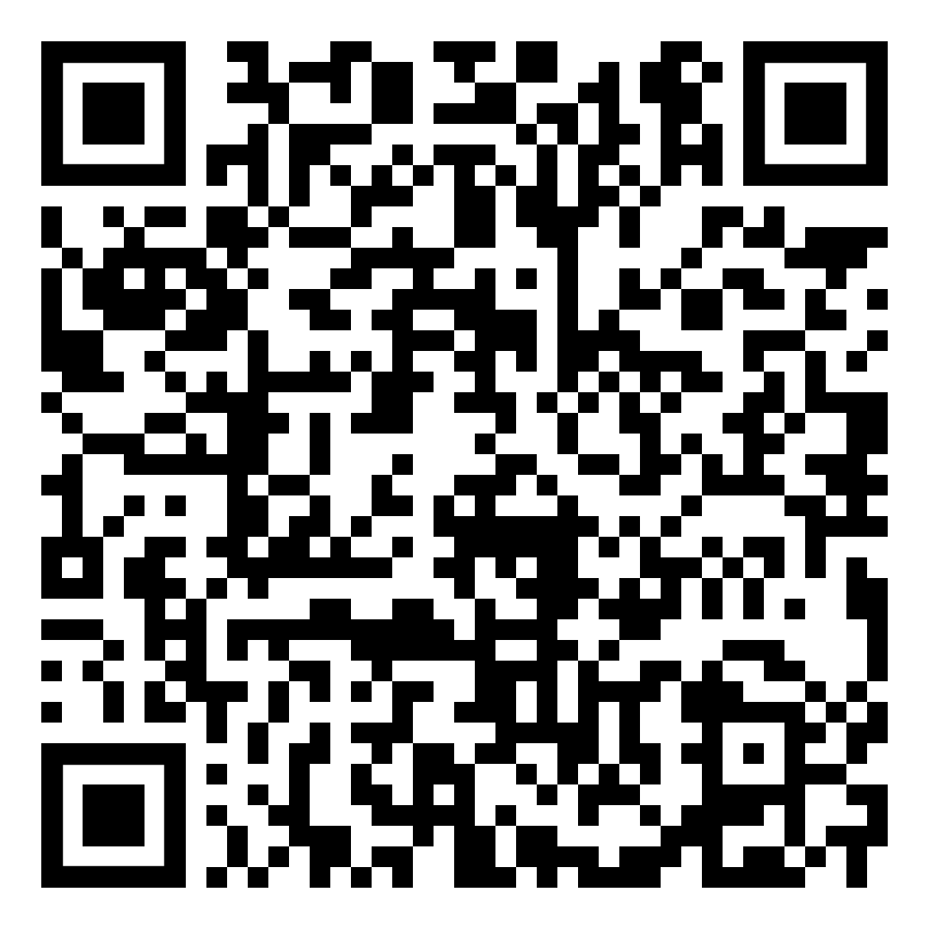
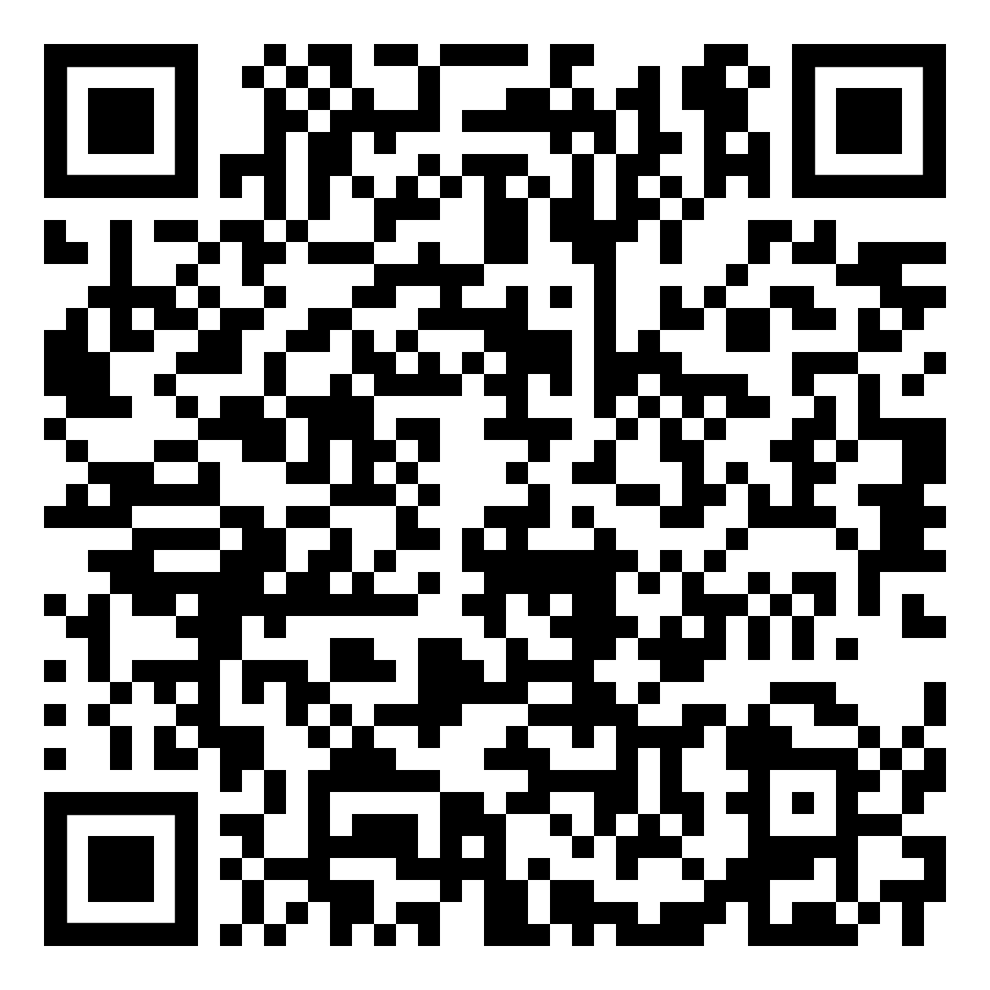

3. FIGURES
Results of Semantic Plausibility in ASC and CS Experiments
Figure S1. Correct Production of ASC Sentence Types with Semantic Plausibility (+SP)

Figure S1 shows the t-test of differences between Group performance on each sentence type (finite) for +SP. For example, for Right-Branching Forward Pronoun sentences, the t-test of differences between the HY group and HA group yields a t-statistic of 0.48 and a p-value of 0.63.

Figure S2. Correct Production of ASC Sentences with Semantic Implausibility (-SP)

Figure S2 shows the t-test of differences between Group performance on each sentence type (finite) for -SP. For example, for Right-Branching Forward Pronoun sentences, the t-test of differences between the HY group and HA group yields a t-statistic of 0.13 and a p-value of 0.90.

Figure S3. Correct Production of CS Sentences with Semantic Plausibility (+SP)

Figure S3 shows the t-test of differences between Group performance on each coordinate sentence type for +SP. For example, for Elided sentence type, the t-test of differences between the HY group and HA group yields a t-statistic of 1.22 and a p-value of 0.22.

Figure S4. Correct Production of CS Sentences with Semantic Implausibility (-SP)

Figure S4 shows the t-test of differences between Group performance on each coordinate sentence type for -SP. For example, for the Elided sentence type, the t-test of differences between the HY group and HA group yields a t-statistic of 1.24 and a p-value of 0.22.

Regression Tests: Tests of Memory Against Linguistic Performance
Figure S5. Relation of HA and aMCI performance on psycholinguistic task (Adverbial Subordinate Clauses) to performance on BP (Brown Petersen) verbal working memory test.

ASC Total scores include the 8 sentences with nonfinite adjunct clauses (see fn 12, 16, 19 in the main paper). Subsequent tests on just ASC finite sentences do not change significance value of results.

Figure S6. Relation of HA and aMCI performance on psycholinguistic task (Adverbial Subordinate Clauses) to performance on ACE-R memory test.

ASC Total scores include the 8 sentences with nonfinite adjunct clauses (see fn 12, 16, 19 in the main paper). Subsequent tests on just ASC finite sentences do not change significance value of results.

4. TABLES
Table S1. Major Error Categories in ASC Experiment
Percent of imitation errors in each group (percent of items in parentheses).
 |  |  | Main clause |  | Subordinate clause
 | One clause | Structural change | Verb change | Object change | Verb change | Object change
HY (n = 10) | 1.61 (0.42) | 0 (0) | 22.58 (5.83) | 8.06 (2.08) | 25.81 (6.67) | 14.52 (3.75)
HA (n = 24) | 5.23 (1.56) | 3.49 (1.04) | 26.16 (7.81) | 8.14 (2.43) | 20.35 (6.08) | 18.02 (5.38)
MCI (n = 22) | 4.55 (2.27) | 1.52 (0.76) | 27.27 (13.64) | 7.95 (3.98) | 25.76 (12.88) | 15.91 (7.95)
See Scoring Criteria for definition of categories.
A given participant response may contain more than one of the changes displayed in the table.

Results of Semantic Plausibility on EI Anaphora Errors by Factor
Table S2. ASC Experiment Anaphora Errors (RBB vs. RBF) (+SP)
Amount of changes of NP or pronoun in ASC experiment:
Percent of errors in each group (percent of items in parentheses).
 | RBB |  | RBF
 | Pronoun | NP | Pronoun | NP
HY (n = 10) | 0 (0) | 0 (0) | 0 (0) | 20 (5)
HA (n = 24) | 0 (0) | 50 (6.25) | 28.57 (4.17) | 0 (0)
MCI (n = 22) | 0 (0) | 25 (4.55) | 14.29 (4.55) | 0 (0)
Note: See Table 8 in the main paper for examples of change types.
Only errors which maintained two clauses are included here.

Table S3. ASC Experiment Anaphora Errors (RBB vs. RBF) (-SP)
Amount of changes of NP or pronoun in ASC experiment:
Percent of errors in each group (percent of items in parentheses).
 | RBB |  | RBF
 | Pronoun | NP | Pronoun | NP
HY (n = 10) | 0 (0) | 50 (5) | 40 (10) | 20 (5)
HA (n = 24) | 0 (0) | 0 (0) | 0 (0) | 0 (0)
MCI (n = 22) | 0 (0) | 100 (18.18) | 21.43 (6.82) | 35.71 (11.36)
Note: See Table 8 in the main paper for examples of change types.
Only errors which maintained two clauses are included here.

5. Supplementary References
Belleville, S., Chertkow, H., & Gauthier, S. (2007). Working memory and control of attention in persons with Alzheimer’s disease and mild cognitive impairment. Neuropsychology, 21(4), 458-469. https://doi.org/10.1037/0894-4105.21.4.458
Bruening, B. (2014). Precede-and-command revisited. Language, 90(2), 342-388. https://doi.org/10.1353/lan.2014.0037
Büring, D. (2005). Binding theory. Cambridge University Press, Cambridge, UK.
Collins, C., & Postal, P. M. (2012). Imposters: A study of pronominal agreement. MIT Press.
Fox, D. (2000). Economy and Semantic Interpretation. Cambridge, Mass: MIT Press.Fraser, K. C., Meltzer, J. A., & Rudzicz, F. (2016). Linguistic features identify Alzheimer’s disease in narrative speech. Journal of Alzheimer’s Disease, 49(2), 407-422. https://doi.org/10.3233/JAD-150520
Gundel, J. K., & Hedberg, H. (Eds.). (2008). Reference: Interdisciplinary perspectives. Oxford: Oxford University Press.
Heim, I. (1998). Anaphora and semantic interpretation: A reinterpretation of Reinhart’s approach. The interpretive tract (MIT Working Papers in Linguistics 25), 205-246.
Heim, I., & Kratzer, A. (1998). Semantics in generative grammar. Blackwell Publishing.
Jacobson, P. (2022). No I’m not on mute: I actually didn’t say anything. Paper at You’re on Mute Workshop. May 6, 2022.
Johnson, N., Barion, A., Rademaker, A., Rehkemper, G., & Weintraub, S. (2004). The Activities of Daily Living Questionnaire: A Validation Study in Patients with Dementia. Alzheimer Disease and Associated Disorders, 18(4), 223-230.
Johnson, K. (2013). Pronouns vs. definite descriptions. In M. Becker, J. Grinstead & J. Rothman (Eds). Generative linguistics and acquisition: Studies in honor of Nina M. Hyams (pp. 157-184). John Benjamins Publishing.
Lust, B., Flynn, S., Sherman, J. C., Gair, J., Henderson, C., Cordella, C., Whitlock, J., Mancuso, S., Chen, Z., Costigan, A., & Immerman, A. (2015). Reversing Ribot: Does regression hold in language of prodromal Alzheimer’s disease? Brain and Language, 143, 1-10. https://doi.org/10.1016/j.bandl.2015.01.013
Lust, B., Flynn, S., Sherman, J. C., Henderson C., Gair, J., Harrison, M., & Shabo, L. (2017). On the biological foundations of language: Recent advances in language acquisition, deterioration, and neuroscience begin to converge. Biolinguistics, 11, 115-138. https://doi.org/10.5964/bioling.9081
Mak, W. M., & Sanders, T. (2010). Incremental discourse processing: How coherence relations influence the resolution of pronouns. In M. Everaert, T. Lentz, H. de Mulder, Ø. Nilsen & A. Zondervan (Eds.), The Linguistic enterprise: From knowledge of language to knowledge in linguistics (pp. 167-182). John Benjamins. http://doi.org/10.1075/la.150.07mak
Mioshi, E., Dawson, K., Mitchell, J., Arnold, R., & Hodges, J. R. (2006). The Addenbrooke's Cognitive Examination Revised (ACE-R): a brief cognitive test battery for dementia screening. International journal of geriatric psychiatry, 21(11), 1078-1085. https://doi.org/10.1002/gps.1610
Morris, J. C. (1993). The clinical dementia rating (CDR): Current version and scoring rules. Neurology, 43(11), 2412-2414.
Morris, J. C., Weintraub, S., Chui, H. C., Cummings, J., DeCarli, C., Ferris, S., Foster, N. L., Galasko, D., Graff-Radford, N., & Peskind, E. R. (2006). Uniform Data Set (UDS): clinical and cognitive variables and descriptive data from Alzheimer Disease Centers. Alzheimer Disease and Associated Disorders, 20(4), 210-216.
Park, D. C., Lautenschlager, G., Hedden, T., Davidson, N. S., Smith, A. D., & Smith, P. K. (2002). Models of visuospatial and verbal memory across the adult life span. Psychology and Aging, 17(2), 299-320. https://doi.org/10.1037/0882-7974.17.2.299
Patel-Grosz, P., Grosz, P. G., & Zobel, S. (Eds.). (2018). Pronouns in embedded contexts at the syntax-semantics interface. Springer International Publishing.
Reinhart, T. (1981). Definite NP Anaphora and C-Command Domains. Linguistic Inquiry, 12(4), 605-635.
Reinhart, T. (1983a). Anaphora and semantic interpretation. Croom Helm, London. https://doi.org/10.4324/9781315536965
Reinhart, T. (1983b). Coreference and bound anaphora: A restatement of the anaphora questions. Linguistics and Philosophy, 6(1), 47-88.
Reinhart, T. (1986). Center and periphery in the grammar of anaphora. In B. Lust (Ed), Studies in the acquisition of anaphora: Defining the constraints (Studies in Theoretical Psycholinguistics, Vol. 1, pp. 123-150). Springer, Dordrecht. https://doi.org/10.1007/978-94-009-4548-7_3
Reinhart, T. (2006). Interface strategies: Optimal and costly computations (Linguistic Inquiry Monographs 45). MIT Press.
Reuland, E. (2011). Anaphora and language design. Cambridge, MA: MIT Press.
Sherman, J. C., Henderson, C., Flynn, S., Gair, J., & Lust, B. (2021). Language decline characterizes amnestic MCI independent of cognitive decline. Journal of Speech, Language and Hearing Research, 64(11), 4287-4307. https://doi.org/10.1044/2021_JSLHR-20-00503
Weintraub, S., Salmon, D., Mercaldo, N., Ferris, S., Graff-Radford, N. R., Chui, H., Cummings, J., DeCarli, C., Foster, N. L., Galasko, D., Peskind, E., Dietrich, W., Beekly, D. L., Kukull, W. A., & Morris, J. C. (2009). The Alzheimer's Disease Centers' Uniform Data Set (UDS): the neuropsychologic test battery. Alzheimer disease and associated disorders, 23(2), 91-101. https://doi.org/10.1097/WAD.0b013e318191c7dd

6. Abbreviations
Abbreviation:
ACE-R Addenbrookes’s-revised (Addenbrook Cognitive Examination-Revised)
AD Alzheimer’s Disease
ADL-Q Activities of Daily Living–Questionnaire
ADRC Alzheimer’s Disease Research Center
ADNI Alzheimer’s Disease Neuroimaging Initiative
aMCI amnestic subtype/MCI
ASC adverbial subordinate clauses
B Backward
BD branching direction
BP Brown-Peterson
BT Binding Theory
CDR clinical dementia rating
C-I Conceptual-Intentional
CITRA Cornell Institute for Translational Research on Aging
CS coordinate sentences
CT Coordination Type
EI elicited imitation
F Forward
HA healthy aging
HY Healthy Young
IPL inferior parietal lobule
L Left
MCI Mild Cognitive Impairment
MGH Massachusetts General Hospital
NART North American Reading Test
NP Noun Phrase
PAC Psychology Assessment Center
POB primitives of binding
PPA Primary Progressive Aphasia
R Right
RBB right-branching backward
RB right-branching
SP semantic plausibility
STG Superior Temporal Gyrus
UDS Uniform Data Set

They also received one other psycholinguistic test of complex sentences, which we reported in Sherman et al., 2021 and Lust et al., 2015, 2017.

