Binding and Coreference Dissociate in Mild Cognitive Impairment
Suzanne Flynn¹, Janet Cohen Sherman², Charles Henderson Jr.³, James Gair⁴ and Barbara Lust³

¹Massachusetts Institute of Technology (sflynn@mit.edu), ²Mass General Hospital and Harvard University (jsherman@mgh.harvard.edu), ³Cornell University (bcl4@cornell.edu), ⁴Cornell University (in Memoriam)
Linguistic Society of America, January 7-10, 2021, 95th Annual Meeting Virtual

Main Message:
EXPERIMENTAL DESIGNS REVEAL THAT COMPLEX SENTENCE COMPUTATION SIGNIFICANTLY DETERIORATES IN MILD COGNITIVE IMPAIRMENT (MCI), PRECURSOR TO ALZHEIMER’S DISEASE (AD). THIS DETERIORATION TARGETS THE LANGUAGE FACULTY AT THE INTERFACE OF CORE SYNTAX WITH CONCEPTUAL-INTENTIONAL (CI) PROCESSING. SPECIFICALLY, IT TARGETS ANAPHORA COMPUTATION INVOLVING FREE REFERENCE WHILE PRESERVING BINDING.

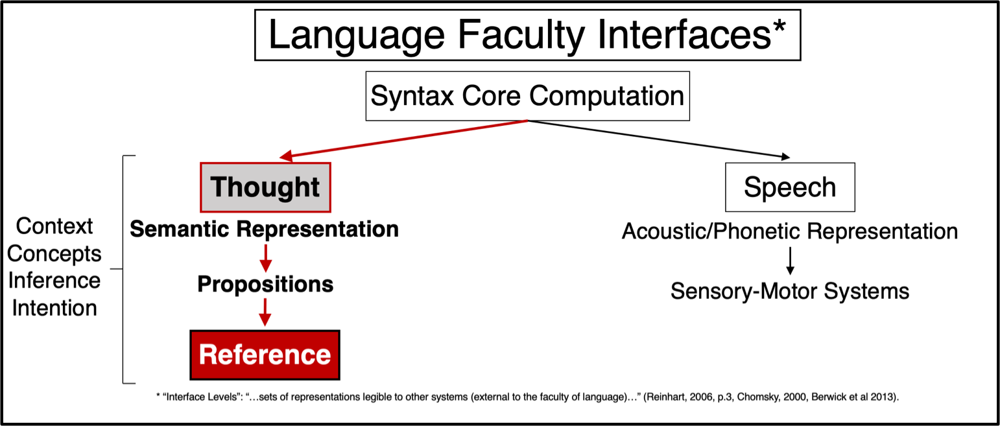

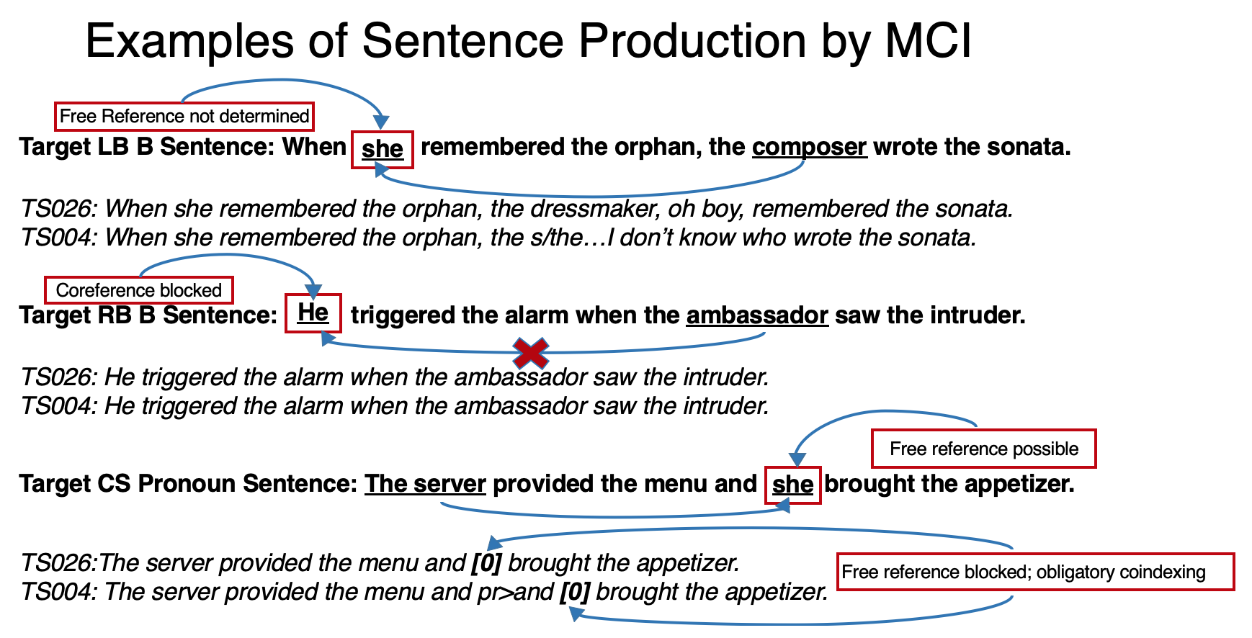

Introduction:
At the interfaces of the Language Faculty, core syntactic computation integrates with cognitive thought and computation (The C-I interface). Anaphora straddles this interface, integrating both core syntax (binding) and externalization (coreference).

Previous research (e.g., Lust et al 2017) has suggested that progressive language loss in Alzheimer’s Disease (AD) initiates at the C-I interface while preserving core syntax.

Evidence of cognitive deterioration has appeared in amnestic Mild Cognitive Impairment (aMCI), although it is characterized primarily by memory loss and higher probabilities of AD progression as well as neural degeneration (e.g., Petersen, 2004).

Leading Questions:
Does language deterioration characterize prodromal AD, e.g., Mild Cognitive Impairment (MCI), and what is its nature?

If core syntax involves binding (Reinhart 2006, Reuland 2011), and deterioration occurs at the interface, will language deterioration in aMCI first selectively impair free reference, while preserving the core syntax of structure dependence and binding?

Design:
Through cross-institutional interdisciplinary collaboration, test three populations: MCI, HA (Healthy Aging), and HY (Healthy Young) in linguistic as well as cognitive tasks through experimental methods. We report selected results from two of the linguistic experiments here. One testing adverbial subordinate clause constructions, one testing coordinate sentences.

Method:
Experimental Factorial Designs of Complex Sentences involving anaphora and elicited language production vary sentences in both semantic (Semantic Plausibility) and syntactic structure (Branching Direction and Linearity). While both sentence sets allow potential coreference, they vary in potential for binding, and/or obligatory co-indexing. (Sentence internal anaphora is blocked in the ASC sentences (Experiment 1) marked in red by Binding Theory, Principle C. It is obligatory in those CS sentences (Experiment 2) marked in green.)

- Adverbial Subordinate Clauses (ASC) (‘when’ subordinate clauses)
- Finite ASC Sentences (pronoun subjects) : 2x2x2=8 conditions, 16 sentences.
Semantic Plausibility (+/-), x Branching Direction (right or left) x Linearity of Pronoun (Forward or Backward)
- Non-finite ASC Sentences (null subjects) : 2x2=4 conditions, 8 sentences
Semantic Plausibility (+/-) x Branching-Null (RB Forward Null/ LB Backward Null).
- Coordinate Sentences (CS) (Sentential coordinate clauses)
CS Sentences: 2x3=6 conditions, 12 sentences
Semantic Plausibility (+/-) x Subject Type (NP, Lexical Pronoun, null)

Experimental Sentence Controls:
Length (17 syllables), lexical frequency, lexical semantic associativity, and all other aspects of structure other than targeted variables; one replication item per condition.

Participants:
Group | N | Age: Mean | Age: Range | Females | Education
 |  |  |  |  | Mean | Range
HY | 10 | 23 | 21 – 27 | 5 | 15.6 | 14 – 18
HA (Cornell) | 14 | 71 | 65 – 80 | 7 | 16.71 | 12 – 20
HA (MGH PAC) | 10 | 77 | 62 – 87 | 6 | 17.60 | 16 – 20
HA Totals | 24 | 74 | 62 – 87 | 13 | 17.15 | 12 – 20
aMCI (MGH PAC) | 22 | 75 | 68 – 88 | 10 | 16.86 | 12 – 20
aMCI (MGH ADRC) | 39 | 79 | 58 – 98 | 23 | 16 | 10 – 20
MCI Totals | 61 | 77 | 58 – 98 | 33 | 16.43 | 10 – 20
Healthy Young (HY) participants were collected at MIT. Healthy Aging (HA) participants were recruited at Cornell University from a CITRA database of an aging population in the Ithaca, NY area (N=14), and from a control group collected at MGH PAC (N=10). MCI participants were collected from MGH Psychology Assessment Clinic (PAC). Additional MCI participants were recruited from MGH from the Alzheimer’s Disease Research Center (ADRC) for the CS experiment only. All participants in this study reported no history of neurological disorder or events.

Task:
Elicited Imitation (EI) elicits language production; it requires the analysis and generative reconstruction of both syntactic and semantic factors involved in a sentence model, thus revealing linguistic computation (Blume and Lust, 2016, Lust et al 1996). Patterns in successful performance and reformations in responses (errors) evidence this computation. Experimental factorial designs allow assessment of factors involved in language production (and indirectly also comprehension). (See Scoring criteria in QR #1).

Analyses:
- Quantitative analyses of language data through logistic-linear mixed models with binomial error assumption and a logit link function, supplemented by Qualitative analyses through linguistic analyses of imitation errors.
- Mean differences in proportion correct response were examined in a mixed model including fixed classification factors for Group and the sentence types; the interactions among these factors; and individuals as levels of a random factor.

Experimental Sentence by Design:

ADVERBIAL SUBORDINATE CLAUSES (ASC) EXAMPLES
+SEM | Pronoun | Right Branching | Forward | A3 | The dressmaker mended the costume when she encountered the actress.
 |  |  |  | B2 | The electrician fixed the light switch when he visited the tenant.
 |  |  | Backward | A1 | He triggered the alarm when the ambassador saw the intruder.
 |  |  |  | B3 | She answered the telephone when the receptionist heard the caller.
 |  | Left Branching | Forward | A2 | When the professor understood the scholar, he explained the theory.
 |  |  |  | B5 | When the announcer introduced the visitor, she read the greeting.
 |  |  | Backward | A4 | When she remembered the orphan, the composer wrote the sonata.
 |  |  |  | B6 | When he summoned the tourist, the gentleman indicated the road.
 | Null | Right Branching | Forward | A6 | The chef assembled the casserole when instructing the apprentice.
 |  |  |  | B4 | The instructor demonstrated the rule when lecturing the pupil.
 |  | Left Branching | Backward | A5 | When babysitting the infant, the grandmother skimmed the newspaper.
 |  |  |  | B1 | When examining the soldier, the medic assessed the injury.
-SEM | Pronoun | Right Branching | Forward | A2 | The programmer concealed the pen when she contacted the candidate.
 |  |  |  | B3 | The navigator imagined the plant when he offended the queen.
 |  |  | Backward | A3 | He labeled the painting when the astronomer pushed the resident.
 |  |  |  | B5 | She measured the artifact when the storyteller paid the boyfriend.
 |  | Left Branching | Forward | A6 | When the employee discouraged the artist, she exchanged the bucket.
 |  |  |  | B4 | When the disciple abandoned the teenager, he dropped the coffee.
 |  |  | Backward | A5 | When she respected the hunter, the drummer buried the replica.
 |  |  |  | B6 | When he misled the neighbor, the deputy inherited the ball.
 | Null | Right Branching | Forward | A1 | The guest jeopardized the violin when refuting the minister.
 |  |  |  | B2 | The companion adjusted the device when tackling the worker.
 |  | Left Branching | Backward | A4 | When awakening the user, the believer broke the piano.
 |  |  |  | B1 | When pursuing the painter, the leader destroyed the binoculars.

COORDINATE SENTENCES (CS) EXAMPLES
+SEM | Expanded | NP | A3 | The student opened the backpack and the student erased the blackboard.
 |  |  | B1 | The postman sorted the mail and the postman delivered the package.
 |  | Pronoun | A2 | The server provided the menu and she brought the appetizer.
 |  |  | B3 | The firefighter organized the equipment and he started the pump.
 | Elided |  | A1 | The babysitter emptied the bottle and prepared the formula.
 |  |  | B2 | The mechanic replaced the transmission and repaired the suspension.
-SEM | Expanded | NP | A5 | The driver offered the onion and the driver misplaced the checkbook.
 |  |  | B4 | The plumber damaged the book and the plumber requested the apple.
 |  | Pronoun | A6 | The banker accepted the guitar and he watched the escalator.
 |  |  | B5 | The hitchhiker selected the document and she mentioned the farm.
 | Elided |  | A4 | The perpetrator cherished the filter and noted the stereo.
 |  |  | B6 | The astronaut purchased the alcohol and recalled the hurricane.

Results:
- In both ASC and CS experiments, aMCI results are significantly depressed relative to HA and HY (Figure 1, 2, 3).
- At the same time, in ASC (finite-pronoun), all groups including MCI are sensitive not only to SP (Semantic Plausibility) (depressing successful production overall) but also to structural factor of BD, significantly favoring RB (F 5.87, (799) p.02); Linearity (Pronoun F or B) is not significant (F 1.95, (799), p. 16). No significant interactions with group (Figure 1).
- In ASC (finite-pronoun), MCI significantly fail production of sentences like A2, A3 and A4 where free reference must be resolved for sentence interpretation (means .48, .37 and .48 respectively, striped on figure) compared to HA (means .68, .57, .59) and HY (.72, .85, .78) (Figure 1)
- But they perform as well as HA on sentences that grammatically block free reference, e.g., A1, cohering with Binding Theory Principle C (MCI .61; HA .69, HY .85) (Figure 1).
- In CS, although MCI do not differ significantly from HA in producing elided sentences, e.g., CS A1(green), they significantly fail on coordinate sentences with a pronoun like CSA2 which allow free reference (mean MCI compared to HA and HY, .34, .74, .74). Qualitative analyses of errors show MCI productively (41% of items, 95% errors) converting the pronoun to a null, a structure with an obligatory co-indexed subject (Figure 3).
- MCI subjects do not generally eschew pronouns. In ASC (non-finite-null) which do not involve a binding structure, they frequently convert RB non-finite clauses to finite, adding a pronoun subject and tense, linking this null-pronoun conversion to BD (Figure 2).

Percent Correct Across All Groups
Standard Error in parenthesis; bold = significant at ≤.05
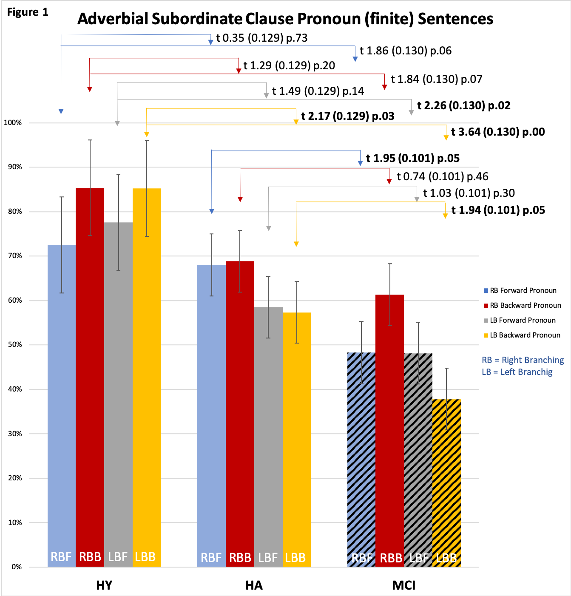

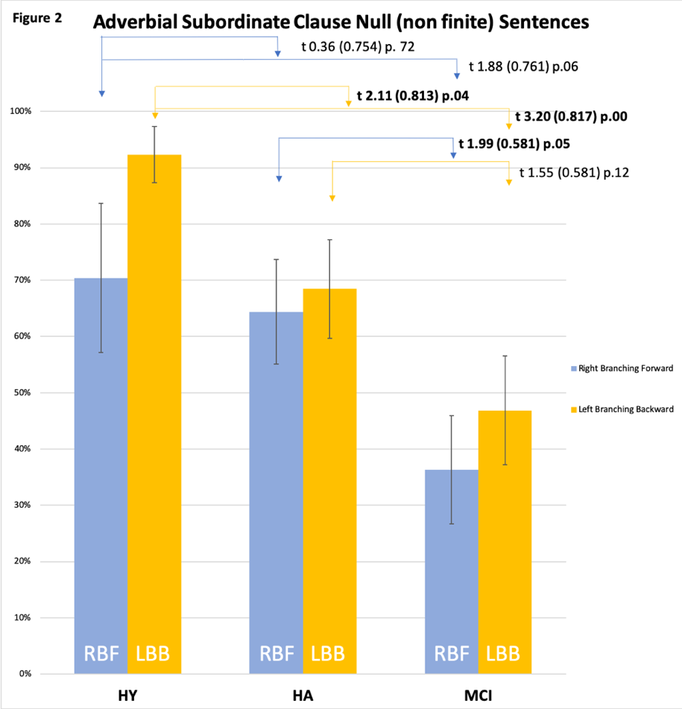

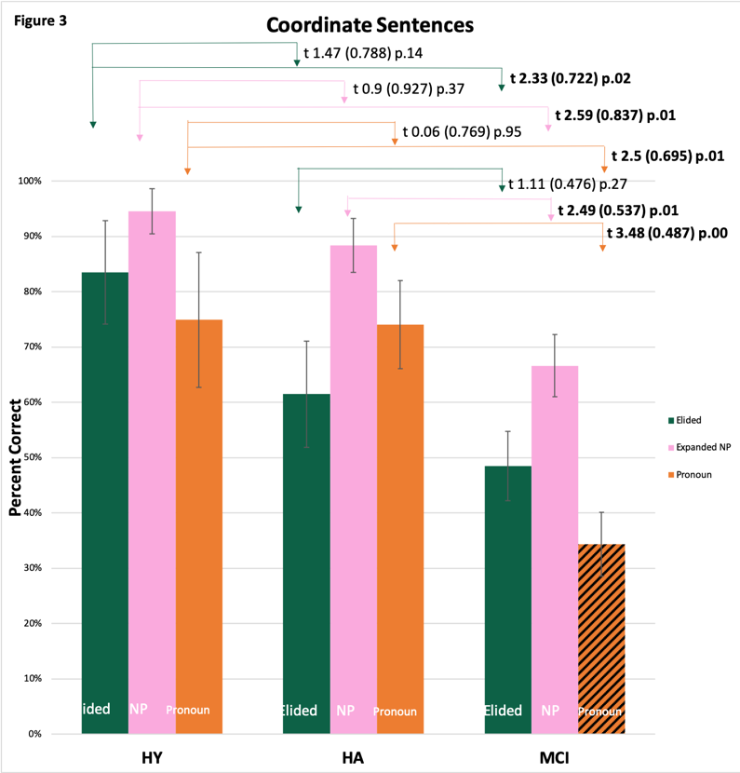

Conclusions:
Significant language impairment appears in complex sentences in aMCI in contrast to healthy aging.

This early language impairment selectively affects free reference in anaphora computation, while preserving structure-dependence of binding.

Results provide empirical support both for the interface model of the Language Faculty and for the essential insight of Reinhart’s (1983) theory of binding: binding is a core grammar computation and is the unmarked assumption. Coreference occurs at the conceptual-intentional (thought) interface, and involves cognitive computation involving pragmatics and semantics necessary to reference resolution through context (e.g., Gundel 1993, Gundel and Heidberg 2008). Language deterioration begins at this interface even while core grammar of binding is preserved. (cf. Kempler et al 1987, Kemper et al 1993)

Open Questions:
What underlies tacit knowledge of ‘binding’? To what degree is c-command essential? (Reinhart 2006, p.169 f; Heim 1998, Buring 2005 and Reuland 2011 for review,)

What other language constructions replicate this dissociation in language deterioration?

To what degree is this deterioration independent of cognitive-memory impairment? (cf. Sherman et al submitted)

References:
Berwick, R, Friederici, A., Chomsky, N., and J. Bolhuis (2013) Evolution, brain and the nature of language. TCS, 17 (2), 89-98.

Blume, M and Lust, B. (2016) Research Methods in Language Acquisition. Mouton de Gruyter and APA. Washington DC.

Buring, Daniel (2005). Binding Theory. Cambridge University Press, Cambridge, UK.

Buring, Daniel (2005) Remarks and Replies. Bound to Bind. Linguistic Inquiry, 36 (2), 259-274

Chomsky, N. (2000) Minimalist Inquiries: The Framework. In R. Martin, D. Michaels and J. Uriagereka (eds). Step by step: Essays on minimalist syntax in honor of Howard Lasnik. 89-157. Cambridge, Ma. MIT Press.

Friederici, A.D. (2017). Language in our brain. The origins of a uniquely human capacity. Cambridge, Ma:MIT press.

Grodzinsky, Y and Reinhart, T. (1993) The innateness of Binding and Coreference. Linguistic Inquiry, 24 (1), 69-101.

Gundel, J. et al (1993). Cognitive Status and the Form of Referring Expressions in Discourse.Language. 69 (2), 274-307.

Gundel, J. and N. Hedberg (eds) (2008) Reference: Interdisciplinary Perspectives. Oxford University Press.

Heim, Irene (1998) Anaphora and Semantic Interpretation: A Reinterpretation of Reinhart’s Approach. The Interpretive Tract. MIT Working Papers in Linguistics 25, 205-246.

Heim, Irene and Angela Kratzer (1998) Semantics in Generative Grammar, (especially chapter 9 and 10), Blackwell Publishing.

Kemper, S. (1988) Geriatric psycholinguistics: syntactic limitations of oral and written language. In Light and D. Burke (eds). Language, memory and aging. 58-76

Kemper, S. (1986) Imitation of complex syntactic constructions by elderly adults. Applied Psycholinguistics 7, 277-288.
Kemper, S. (1987). Life-span changes in syntactic complexity. Journal of Gerontology, 42(3), 323-328.
Kemper, S. (1988). Geriatric psycholinguistics: Syntactic limitations of oral and written language. Language, memory and aging. N.Y.: Cambridge Univ. Press.
Kemper, S., & Kemtes, K. (1999). Limitations on Syntactic Processing. In Kemper and Kliegl (Eds.), Constraints on Language. Aging, Grammar and Memory (pp. 79-106). Norwell, MA: Kluwer Academic Publishers.
Kemper, S., & Kliegl, R. (Eds.). (1999). Constraints on Language. Aging, Grammar and Memory. Norwell, MA: Kluwer Academic Publishers.
Kemper, S., LaBarge, E., Ferraro F.R., Cheung, E., Cheung, H, Storandt, Martha (1993). On the Preservation of Syntax in Alzheimer’s Disease. Archives of Neurology 50(1), 81.

Kemper, S., Thompson, M and Marquis, J. (2001). Longitudinal Change in language production: Effects of aging and dementia on grammatical complexity and semantic content. Psychology and Aging, 16, 600-614.
Kempler, D. (1995). Language changes in dementia of the Alzheimer type. Dementia and Communication: Research and Clinical Implications, 98-114.
Kempler, D., Almor, A., & MacDonald, M. C. (1998). Teasing apart the contribution of memory and language impairments in Alzheimer's disease: An online study of sentence comprehension. American Journal of Speech-Language Pathology, 7(1), 61-67.
Kempler, D., Almor, A., MacDonald, M. C., & Andersen, E. S. (1999). Working with limited memory: Sentence comprehension in Alzheimer’s disease. In S. Kemper, & R. Kliegl (Eds.), Constraints on language: Aging, grammar and memory (pp. 227-246). Norwell, MA: Kluwer.Academic Publishers.
Kempler, D., Curtiss, S., & Jackson, C. (1987). Syntactic preservation in Alzheimer’s disease. Journal of Speech and Hearing Research, 30(3), 343-350.
Kempler, D., & Goral, M. (2008). Language and dementia: Neuropsychological aspects. Annual review of applied linguistics, 28, 73-90.
Kempler, D., & Zelinski, E. M. (1994). Language in dementia and normal aging. Dementia and Normal Aging, 331-365.
Lust, B, Flynn, S, Sherman, J C, Gair, J, Henderson, C, Cordella, C, Whitlock, J, Chen, Z, Mancuso, S, Immerman, A, Costigan, A. (2015). Reversing Ribot: Does regression hold in language of prodromal Alzheimer’s disease? Brain and Language.143, 1-10.

Lust, B., Flynn, S., Cohen Sherman, J., Henderson, C., Gair, J., Harrison, M and Shabo, L.(2017). On the Biological Foundations of Language: Recent Advances in Language Acquisition, Language Deterioration and Neuroscience Begin to Converge. Biolinguistics:. Volume 11.115-137. (http://biolinguistics.eu/index.php/biolinguistics/article/view/524).

Lust, B, Flynn, S and Foley, C (1996). What Children Know about What They Say: Elicited Imitation as a Research Method for Assessing Children's Syntax. In Methods for Assessing Children's Syntax, edited by Dana McDaniel, Cecile McKee, and Helen Smith Cairns. Cambridge, Mass.: MIT Press, 55-76.

Lust, B. et al (in prep). Disintegration of the Syntax-Semantics Interface in Prodromal Alzheimer’s Disease: New Evidence from Complex Sentence Formation in Mild Cognitive Impairment.

McCullough, K., Bayles, K. and E. Bouldin. (2019). Language Performance of Individuals at Risk for Mild
Cognitive Impairment. J. Speech, Language and Hearing Research, vol 62(3).

Petersen, R.C. (2004). Mild cognitive impairment as a diagnostic entry. Journal of Internal Medicine, 256, 183.

Petersen, R. (ed). (2003). Mild Cognitive Impairment: Aging to Alzheimer’s disease. Oxford: Oxford University Press.

Reinhart, T. (2006). Interface Strategies. Linguistic Inquiry. Monograph 45. MIT Press.

Reinhart, T. (1983) Anaphora and Semantic Interpretation. Croom Helm, London.

Reinhart, T. (1986) Center and Periphery in the Grammar of Anaphora. In Lust, B. ed Studies in the Acquisition of Anaphora. Volume 1. Defining the Constraints, D. Reidel Publishing Co.

Reuland, E. (2011) Anaphora and Language Design. Cambridge, Ma: MIT Press.

Sherman, J.Cohen (submitted). Language Decline Characterizes Amnestic MCI independent of Cognitive Decline.

Szatloczki, G, Hoffmann, I, Vincze, V, Kalman, J and Pakaski, M. (2015). Speaking in Alzheimer’s
disease, is that an early sign? Importance of changes in language abilities in Alzheimer’s disease.
Frontiers in Aging Neuroscience, 7, article 195.

Acknowledgments:
- Podell Award, Federal Formula Funds, Dr. Brad Hyman at MGH ADRC, Cornell BCLD, Institute for Translational Research, ISSR, Apple.
- The 2020 data analysis team Alexis Waite, Lea Jih-Vieira, Anthony Chen, Noah Endreny, Judy Ng, and Ivy Chen; Dr. Brad Dickerson for comments.

